**Cleaning Up Canvas**

*Finishing the year and Making Canvas Class Easy to Copy for Next Year*

**Finishing This Year**

* **Check for Gradebook Glitches** – If you use the Canvas Gradebook, check to make sure its final grades match the ones on PowerSchool. If there is a discrepancy, your top priority should be to fix this.
* **Do not input final exam score into Canvas** – For high school classes, PowerSchool must be carefully set up to give the final exam a 20% weight for the semester. Unless you have carefully designed Canvas do the same, you’re the two systems will not treat the final the same.   
    
  What I (Steven) tell my students: “Canvas will show you’re your grades up until the final. But only PowerSchool will show your score on the exam and your overall grade in the class.”   
  (I disable Canvas from every telling my students their overall grade.)
* 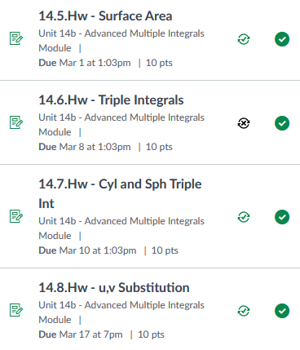**Check Your Sync** – If you sync grades with PowerSchool, click on Assignments and make sure all the appropriate green sync symbols are showing. If one is black, that means it is not syncing.
* **Review Your Recent Sync Successes** – Check to see if your regular syncs have been successful.

**Prepping for Next Year**

* **Undelete** – Did you make an assignment/file/page this year and then delete it, but now you want it back for next year? Every course has an “undelete” section, but you must get there by manually typing in a modified web address. See example below:  
  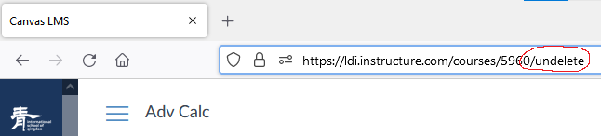
* **Make a List** – If your course has lots of pages and assignments, there might be some that y
* **Large Files Trick** ☺ - Each new Canvas course can only have 512MB of storage. If you have a large file that you know you will want to upload next year, try squeezing it onto a current Canvas course that has some extra space. Then when you get your new course in August, you can import the large files without them counting against your limit for the new course.
* **Beware of Glitch Next Year** – Look at the screenshot below for one of my current classes. The page is part of “Course #5960” it has a link to “Class Resources,” which is part of Class 5960. Suppose I teach the same class next year, but it is #8888. If I import this page, the links will not update. When students try to click on the “Class Resources” link, they will be told, “You do not have access to Course 5960”  
    
  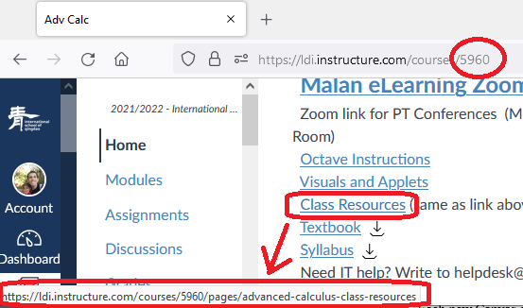

PowerSchool – Do you have your grading scheme set up correctly? (Settings --> Traditional Gradebook Settings)

If you use Canvas to input Grades and sync to PowerSchool:

Assignments – make sure all green checkmarks are there for assignments you want to sync

Tell students that PowerSchool is the king for all final grades. It will calculate the 20% final correctly. (I suggest not entering the grade into Canvas. Maybe just create a “page” with final exam date and info, but no grade spot).